April
This Photo by Unknown Author is licensed under CC BY-NC
This Photo by Unknown Author is licensed under CC BY-NC
Snack | 30  Zoom | 1  Zoom
Snack | 6  Zoom | 8  Zoom
Snack | Spring Break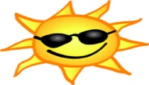  This Photo by Unknown Author is licensed under CC BY-ND
Snack  Jordan | 20 Show and tell: Something that makes you happy!  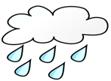  This Photo by Unknown Author is licensed under CC BY-SA  Rain | 22  Rainbows 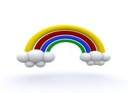  This Photo by Unknown Author is licensed under CC BY
Snack  Deacon | 27 Show and tell: Something you would want as a pet.  Pets | 29  Pets 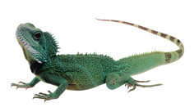

Next months snack:
May 3rd- Josie, May 10th- Eden
May 17th- Ruby, May 24th- Liam

